Lower North Island Rail Integrated Mobility (LNIRIM) Programme: 'Tūhono'

PRODUCT

SHEET

The first battery- electric multiple unit (BEMU) commuter trains in New Zealand -18 Adessia Stream B five-car trains - will be
manufactured and maintained by Alstom over a 35-year period.

Key Information
- Customer: Greater Wellington
- Customer Program: Lower North Island Rail Integrated Mobility
{LNIRIM)
- Train name: 'Tūhono', meaning "to connect" or "to unite."

Seope of Work
- 18 Adessia {formerly known as X'trapolis) Stream B Battery-Electric Multiple Unit {BEMU) commuter trains of five-cars {90 cars total)
- Simulator Equipment {Components)
- Full Maintenance for 35 years including provision for Spares and Materials, Initial Ratable Spares and Special Tools and Insurance Spares
- Alstom will operate a purpose-built maintenance facility in Masterton with provision for certain equipment at depot.

GENERAL DESCRIPTION
Carrying a maximum of 475 passengers per train and operating at speeds up to 120kph, the trains are based on Alstom's globally proven Adessia commuter trains platform and will be adapted to meet the distinct needs of Wellington's operating environment. A comfort­ centric passenger experience will be at the heart of the new trains equipped with wheelchair, bike, luggage and pram amenities onboard with toilet, vending machine and water dispenser facilities.

PROJECT PURPOSE
- Replace the current diesel locomotive-hauled trains due for retirement in 2028/29 with Alstom's bi-mode solution, powered by overhead catenary or onboard traction batteries, enabling zero direct carbon emission operations on non-electrified segments.
- Meet future patronage demands and promote mode-shift to rail.
- Reduce emissions by introducing Battery-Electric Multiple Unit (BEMU) commuter trains for the first time in New Zealand. The trains will enable emission free operations on non-electrified segments of the Wellington rail network.

CURRENT INFRASTRUCTURE:
2 partially electrified lines - 226 km
 | Wairarapa line | Manawatu line
Destination | .  Wellington-Masterton _  : | Wellington – Palmerston North
Length | 91km incl 58.5km electrified | incl 80km non electrified
Stations | 12 | 7



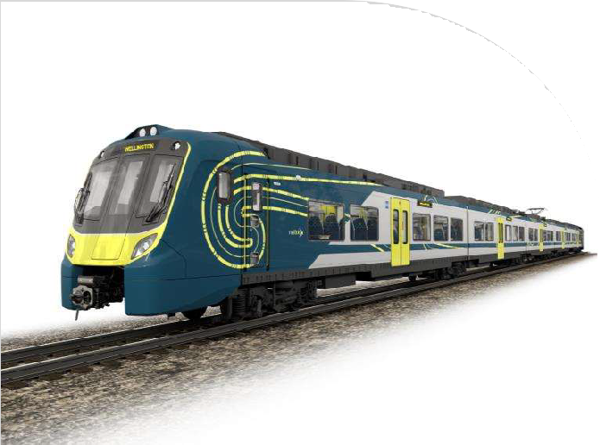

Lower North Island Rail Integrated Mobility (LNIRIM) Programme: 'Tūhono'

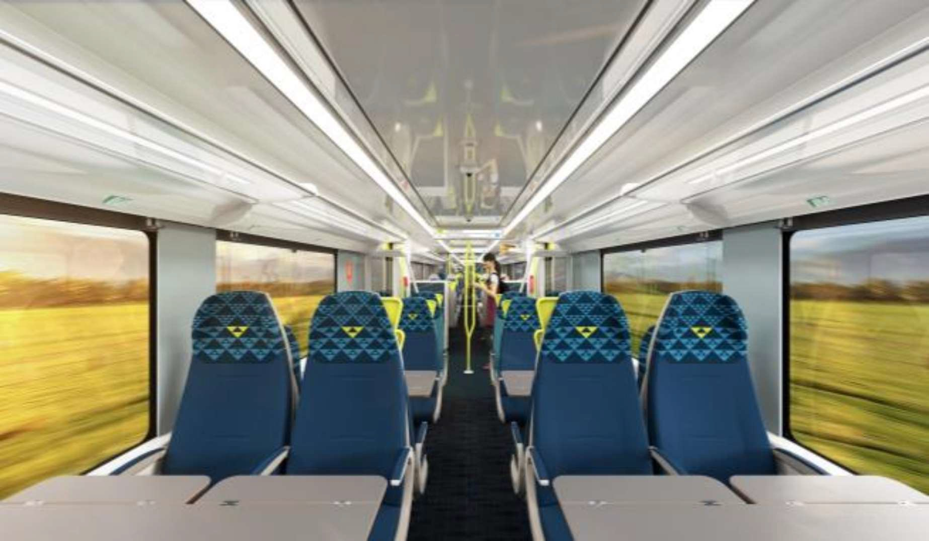
ROLLING STOCK CHARACTERISTICS

- Operating mode: BEMU
- ETCS Level 2 ready
- Maximum speed: 120 kph
- Starting acceleration rate: 0.65 m/s² •
up to 65kph
- Service brake: 0.9 m/s²
cars with fold out steps), 740mm (intermediate cars with low height boarding and platform gap-filler) Passenger seat quantity: 220+11 tip- up seats
- Passenger capacity: 475 passengers

  - Emergency brake: 1.13 m/s² per unit
  - Catenary voltage: 1500 Vdc + battery • 2 wheelchair spaces
in non-electrified areas • 2 bicycle areas located in end cars
  - Track gauge: 1,068 mm • 1 universal toilet & 1 standard toilet
  - Train length: 81.6 m • 1 vending machine & 1 water
  - Entrance height: 915mm (driving dispenser

KEY PROOF POINTS:
Emission-free travel with bi-mode innovation:

Alstom's bi-mode solution-powered by overhead catenary or onboard traction batteries-will replace the current diesel locomotive-hauled fleet, enabling zero emission travel on non-electrified routes including Masterton and Palmerston North, where up to 80km of track remains non-electrified.
Smart connectivity for on-time performance: Integrated Intelligent Train Control and Driver Advisory Systems empower operators with real-time guidance,
optimising punctuality and enhancing network fluidity-even across mixed electrification zones.
Operational resilience in challenging infrastructure:
The Remutaka tunnel, a 9 km stretch with limited ventilation, currently restricts diesel operations. Alstom's Battery Electric Multiple Units (BEMUs) eliminate exhaust emissions, unlocking reliable and safe operations through this critical corridor.

Accessibility without compromise:
With nominal platform heights in lower North Island at 680 mm - all of the train's intermediate cars (740 mm entrance height) enables barrier-free access for all passengers, including those with reduced mobility.
Maximised capacity, optimised flow:
Interior layouts and door configurations are engineered to maximise seating-offering 220 fixed seats and 11 folding seats per 5-car trainset-while maintaining efficient passenger flow and dwell times.
Enhanced safety in constrained environments:
To address the lack of space for lateral detrainment in locations such as narrow tunnels, Tūhono will be fitted with a front detrainment door with both train-to-track and train-to­ train evacuation capabilities-ensuring passenger safety in emergency scenarios.
Total Cost of Ownership (TCO) efficiency:
Featuring a semi-suspended articulated bogie arrangement, Alstom's lightweight architecture reduces energy consumption, enhances performance, and increases low­ floor accessibility-all while meeting axle load constraints, and reducing whole of life costs.
Comfort-centric passenger experience:
Designed with user feedback at its core, the new fleet includes:
- Multi-functional spaces that are adaptable to passenger needs
- 2 wheelchair spaces
- 2 bicycle areas which hold 3 bicycles each
- 1 universal and 1 standard toilet
- Vending machine and water dispenser
- Luggage racks and pram parking.

Alstom's design philosophy delivers not just a train-but a modern, inclusive, and comfortable journey for every passenger.

FOR MORE INFORMATION:
Alstom
48, rue Albert Dhalenne 93482 Saint-Ouen-sur-Seine Cedex - France
Phone: +331 57 06 90 00
www.alstom.com

